**XM125 Configuration Settings Brainstorm on 2/11/2025 w/ Henry:**

Beans should be ~67.5 mm above the radar face on their side (topmost edge w/o lens)

* Stepper motor top will be 71 +/- 2mm
* We want the radar to pass through the beans at an ODD integer multiple of ~7.5mm (60GHz wavelength = 5mm, 1.5x5mm = 7.5mm) for maximum resolution
* Measurement should have a starting point of 37.5mm (15x2.5mm)to act as a buffer
* The step size should be 1 which is 2.5mm
* The endpoint is at 165mm (51 steps from the start) and should be just past the corner reflector

Since we’re comparing accuracy against the RoastRite, we need to use the same sample size of beans.

* What is the minimum amount of beans that can be used w/ the RoastRite to still produce an accurate reading?
  + 155 mL
* Ask Josh if the RoastRite has an instruction manual.

**3D Model Bean Box Dimensions Brainstorm on 2/12/2025 w/ Henry:**

The volume of beans measured must be 155mL to match the RoastRite

* The lens of the radar is ~13/16” = 20.65mm
  + To give some leeway to our measurements, we are suggesting a 1.5 inch = 38.1mm pathway for the radar to measure
  + For an Annular Cylinder, the equation for volume is:
 $V_{AnnularCylinder}=π(h)({r^{2}}_{outer}-{r^{2}}_{inner})$

 + With the given volume of 155ml (155000 mm^3), and a chosen inner diameter of 1 inch, the inner radius will be 12.7mm
  + With our chosen values, the equation then becomes:
 $155000_{mm^{3}}=π(h)((12.7_{mm}+38.1_{mm})^{2}-(12.7_{mm})^{2})$

 + Solving for *h* yields a height of ~27.12435mm

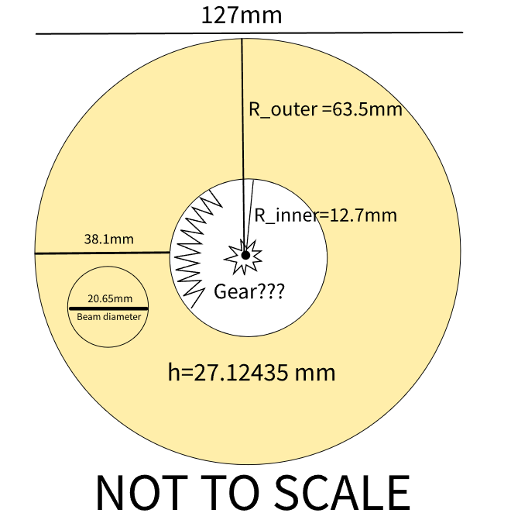

84.8mm diameter container

5mm shaft diameter

2:1 gear ratio

7.2degree steps